
RAMAIAH
Institute of Technology
USN | 1 | M | S

(Autonomous Institute, Affiliated to VTU)
(Approved by AICTE, New Delhi & Govt. of Karnataka) Accredited by NBA & NAAC with ‘A’ Grade

SUPPLEMENTARY SEMESTER EXAMINATIONS – SEPTEMBER 2021
Program | : | B.E. : Electrical and Electronics Engineering | Semester | : | VII
Course Name | : | Power Systems - II | Max. Marks | : | 100
Course Code | : | EE72 | Duration | : | 3 Hrs

Instructions to the Candidates:
- Answer any five full questions.
- Suitably assume any missing data.

1. | a) | The single line-diagram of a network is shown in Fig.1(a). The line reactance is 0.001 pu/km and shunt capacitance is 0.0016 pu/km. Form the bus admittance matrix by inspection neglecting the line resistance.  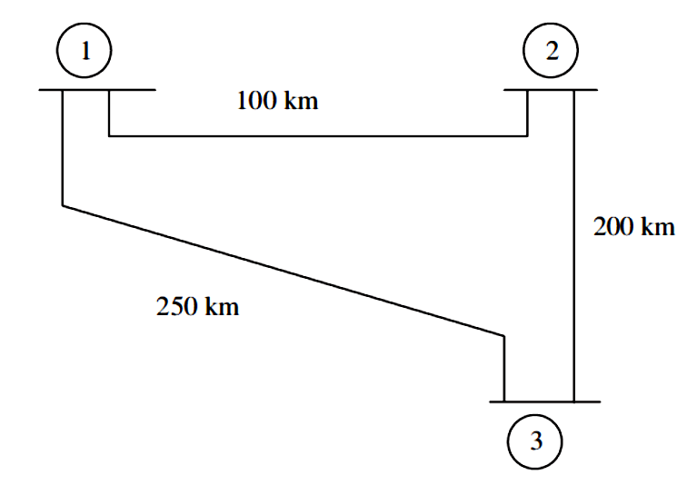  Fig.1(a) | CO1 | (06)
 | b) | Determine Z_{bus} for the power system network shown in the Fig.1(b) using building algorithm. The elements are added in the following order ref.-(1), (1)-(2), (1)-(3), (2)-ref.  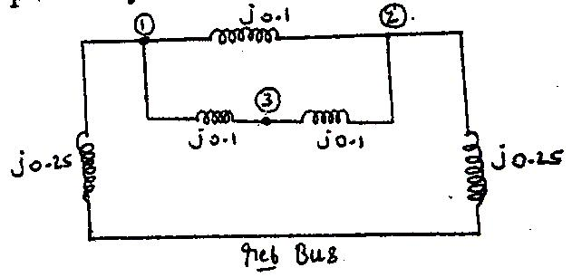  Fig.1(b) | CO1 | (14)
2 | a) | Derive the step-by-step algorithm for formation of bus impedance matrix, when added element to the partial network is link. | CO1 | (10)
 | b) | Form bus admittance matrix by the method of inspection for the system shown in Fig. 2(a). Take a₁ = 0.92 and a₂ = 0.95.  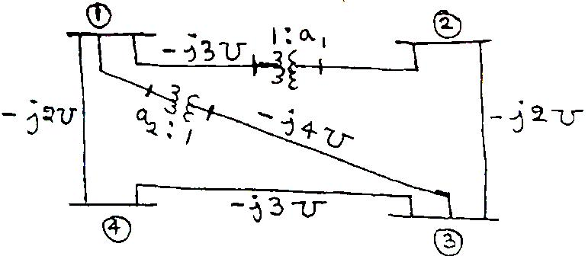  Fig. 2(a) | CO1 | (06)
 | c) | Derive the following terminologies:  - Graph  - Connected graph  - Oriented graph  - Tree . | CO1 | (04)
3. | a) | Discuss in brief the advantages of using bus admittance matrix in power flow analysis. | CO2 | (04)
 | b) | Explain fast decoupled load flow analysis. | CO2 | (08)
 | c) | Using based N-R method of load flow analysis for the power system shown below. Compute at the end of first iteration the Voltage at the buses 2 & 3.  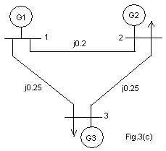 | CO2 | (08)
  Bus | Voltage | Generator |  | Load |  | Remarks
  Bus | Voltage | P | Q | P | Q | Remarks
  1 | 1.20 | - | - | - | - | Slack bus
  2 |  | 0.7 | 0.5 | 0.3 | 0.2 | P.Q
  3 |  | 0 | 0 | 0.6 | 0.4 | P.Q
4. | a) | Explain the significance of Jacobian matrix of N.R power flow analysis. | CO2 | (04)
 | b) | Explain following with respect to power flow analysis:  - Types of buses.  - Importance of controlling bus.  - Constraints for power flow solution. | CO2 | (08)
 | c) | For the network shown in the Fig. 4(c), obtain the complex bus-bar voltages at the end of first iteration using Gauss-Siedal method. Bus-1 is a slack bus with. Take and .  Assume and  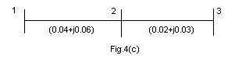 | CO2 | (08)
5. | a) | Derive an expression for Transmission loss formula with necessary assumptions. | CO3 | (10)
 | b) | Determine the economic operation for the three thermal units when delivering a total of 1000MW.  Unit A: Pmax = 600MW, Pmin =150MW  FA=500+7PGA + 0.0015 PGA2  Unit B: Pmax = 500MW, Pmin =125MW  FB=300+7.88PGB + 0.002 PGB2  Unit C: Pmax = 300MW, Pmin =75MW  FC=80+7.99PGC + 0.005 PGC2 | CO3 | (10)
6. | a) | Two power plants are connected together by a transmission line and load at plant-2 as shown in fig.6.b. When 100MW is transmitted from plant-1, the transmission loss is 10MW. The cost characteristics of two plants are  F1=0.05PG12 +13PG1 Rs/Hr  F2= 0.06PG22 +12PG2 Rs/Hr  Find the optimum generation when λ=22, λ=25 and λ=30.  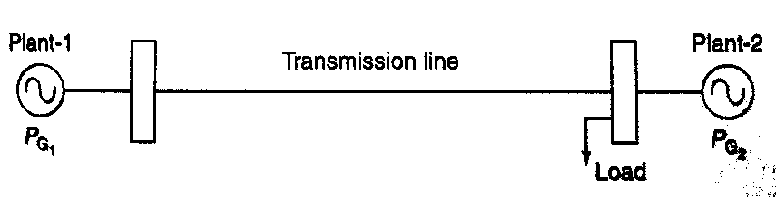 | CO3 | (10)
 | b) | Determine the condition for the economic scheduling of generators without limits and without losses. | CO3 | (06)
 | c) | Define and draw the heat rate curve and incremental fuel rate curve. | CO3 | (04)
7. | a) | Discuss the determination of transient stability of a given power system using point by point method with relevant graphs. | CO4 | (08)
 | b) | Discuss the determination of transient stability of a given power system using Modified Euler’s method. | CO4 | (08)
 | c) | A 20MVA, 50Hz generator delivers 18MW over a double line to an infinite bus. The generator has kinetic energy of 2.52MJ/MVA at rated speed. The generator transient reactance is X_{d}=0.35pu. Each transmission circuit has R=0 and a reactance of 0.4pu on a 20MVA base. E=1.1pu and infinite bus voltage V=1.0∟0º. A three phase short circuit occurs at 40% of the line length from the generator end on one of the transmission lines. Calculate the maximum power transferred with corresponding displacement angle before the fault occurs. | CO4 | (04)
8. | a) | Write swing equation and define the terms involved. | CO4 | (04)
 | b) | A 20MVA, 50Hz generator delivers 18MW over a double line to an infinite bus. The generator has kinetic energy of 2.52MJ/MVA at rated speed. The generator transient reactance is X_{d}=0.35pu. Each transmission circuit has R=0 and a reactance of 0.2pu on a 20MVA base. E=1.1pu and infinite bus voltage V=1.0∟0º. A three phase short circuit occurs at the midpoint of one of the transmission lines. Plot the swing curve with fault cleared at 1st cycle with outage. Use point by point method. | CO4 | (10)
 | c) | Discuss the methods to improve the transient stability of a given power system | CO4 | (06)
9. | a) | Two generators rated 300 MW and 600MW are operating in parallel. The drop characteristics of their governors are 4% and 5% respectively from no-load to full load. Assuming that the generators are operating at 50Hz at no load. How would a load of 900MW be shared between them? What will be the system frequency at this load? Assume free governor operation. | CO5 | (07)
 | b) | Repeat the problem of question 9a) and comment on the result if both the governors have a droop of 4%. | CO5 | (03)
 | c) | Write a brief note on:  (i) Series Compensation and (ii) FACTS Controllers. | CO5 | (10)
10. | a) | Derive mathematical model of speed governing system of steam turbine used in load frequency control problem. Also draw the corresponding block diagram. | CO5 | (10)
 | b) | Write a brief note on:  (i) Load Compensation and (ii) Line Compensation. | CO5 | (10)

****************

